Ethernet (Twisted Pair)

🧵 What Are Ethernet (Twisted Pair) Cables?
# Source: AI Source: Provided by: [Data Path: Persons Table -> ID Column: 1, Name_En Column: Motasem Essam] -> From: [ChatGPT] on [12/18/2025]
Ethernet twisted pair cables are the most common cables used in local area networks (LANs) to transmit data between devices such as computers, switches, and routers. They use pairs of copper wires twisted together to reduce electromagnetic interference (EMI).

Ethernet (Twisted Pair) Image
# Source: ScreenShots Source: Provided by: [Persons Table -> ID Column: 1, Name_En Column: Motasem Essam] -> Tool: [Lightshot Program] -> From [Site: Google Search: Images: Ethernet (Twisted Pair)] on [12/18/2025]
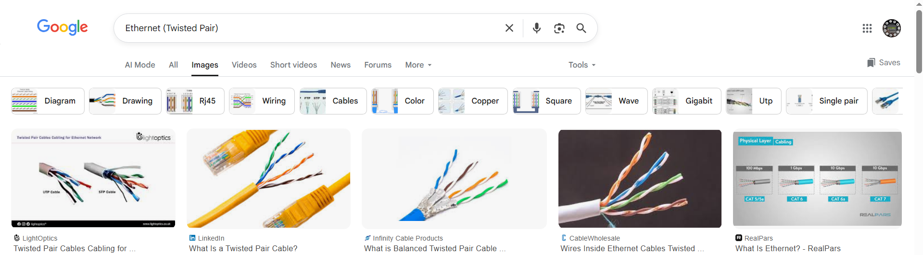

📦 Belongs to:
# Source: AI Source: Provided by: [Data Path: Persons Table -> ID Column: 1, Name_En Column: Motasem Essam] -> From: [ChatGPT] on [12/18/2025]
✅ Types of Network Cables
Specifically under wired (copper-based) transmission media.

🧠 Key Features
# Source: AI Source: Provided by: [Data Path: Persons Table -> ID Column: 1, Name_En Column: Motasem Essam] -> From: [ChatGPT] on [12/18/2025]
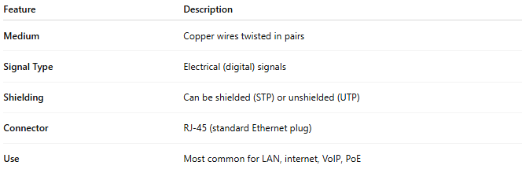
Feature | Description
Medium | Copper wires twisted in pairs
Signal Type | Electrical (digital) signals
Shielding | Can be shielded (STP) or unshielded (UTP)
Connector | RJ-45 (standard Ethernet plug)
Use | Most common for LAN, internet, VoIP, PoE

🧾 Common Ethernet Cable Categories
# Source: AI Source: Provided by: [Data Path: Persons Table -> ID Column: 1, Name_En Column: Motasem Essam] -> From: [ChatGPT] on [12/18/2025]
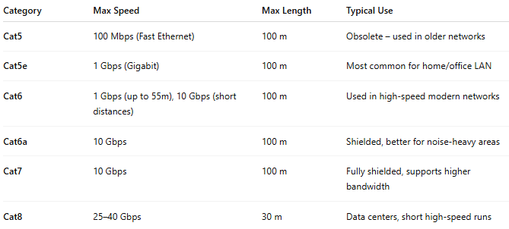
Category | Max Speed | Max Length | Typical Use
Cat5 | 100 Mbps (Fast Ethernet) | 100 m | Obsolete – used in older networks
Cat5e | 1 Gbps (Gigabit) | 100 m | Most common for home/office LAN
Cat6 | 1 Gbps (up to 55m), 10 Gbps (short distances) | 100 m | Used in high-speed modern networks
Cat6a | 10 Gbps | 100 m | Shielded, better for noise-heavy areas
Cat7 | 10 Gbps | 100 m | Fully shielded, supports higher bandwidth
Cat8 | 25–40 Gbps | 30 m | Data centers, short high-speed runs

🧰 STP vs UTP
# Source: AI Source: Provided by: [Data Path: Persons Table -> ID Column: 1, Name_En Column: Motasem Essam] -> From: [ChatGPT] on [12/18/2025]
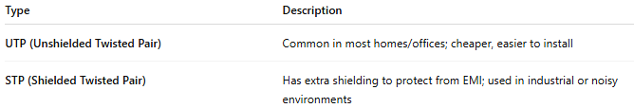
Type | Description
UTP (Unshielded Twisted Pair) | Common in most homes/offices; cheaper, easier to install
STP (Shielded Twisted Pair) | Has extra shielding to protect from EMI; used in industrial or noisy environments

✅ Advantages
# Source: AI Source: Provided by: [Data Path: Persons Table -> ID Column: 1, Name_En Column: Motasem Essam] -> From: [ChatGPT] on [12/18/2025]
- 💸 Inexpensive and widely available
- ⚡ Fast for typical LAN use (1–10 Gbps)
- 🔌 Simple plug-and-play with RJ-45 connectors
- 🔧 Easy to terminate, extend, or replace

❌ Disadvantages
# Source: AI Source: Provided by: [Data Path: Persons Table -> ID Column: 1, Name_En Column: Motasem Essam] -> From: [ChatGPT] on [12/18/2025]
- 📏 Limited distance (usually 100 meters)
- ⚡ More interference than fiber in noisy environments
- 🌧️ Susceptible to damage from weather/moisture (if outdoor and unshielded)

📌 Summary
# Source: AI Source: Provided by: [Data Path: Persons Table -> ID Column: 1, Name_En Column: Motasem Essam] -> From: [ChatGPT] on [12/18/2025]
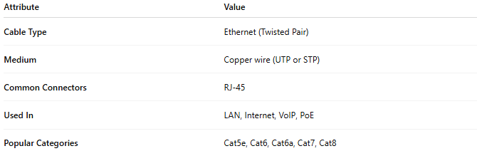
Attribute | Value
Cable Type | Ethernet (Twisted Pair)
Medium | Copper wire (UTP or STP)
Common Connectors | RJ-45
Used In | LAN, Internet, VoIP, PoE
Popular Categories | Cat5e, Cat6, Cat6a, Cat7, Cat8

